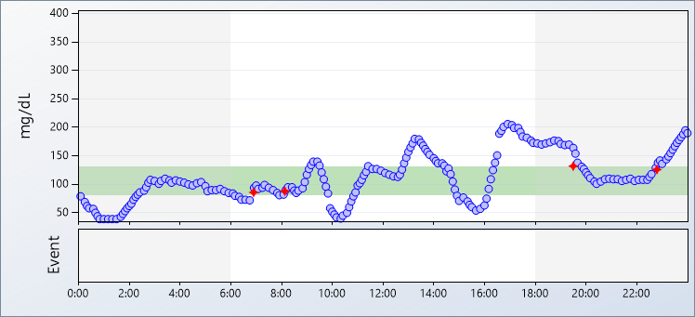 | Monday, November 9, 2015
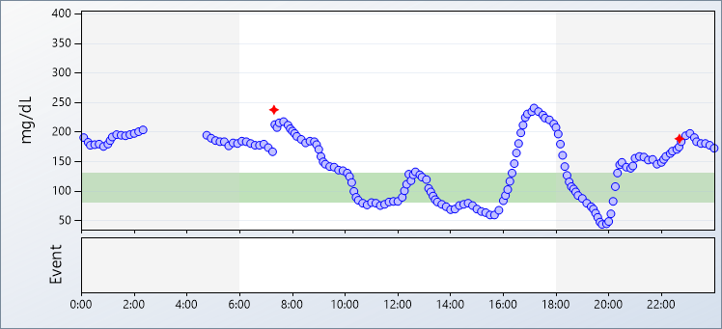 | Tuesday, November 10, 2015
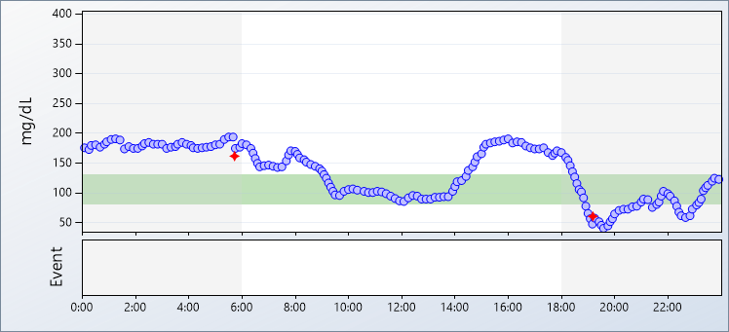 | Wednesday, November 11, 2015
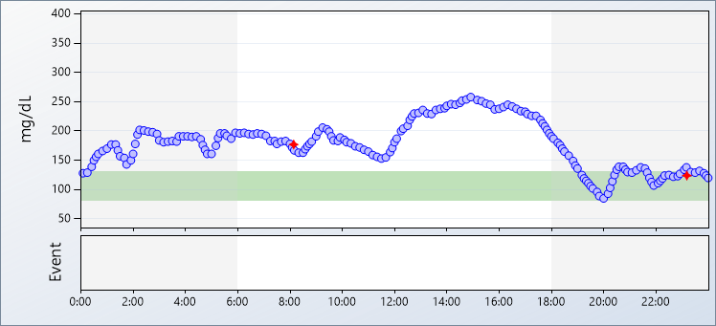 | Thursday, November 12, 2015
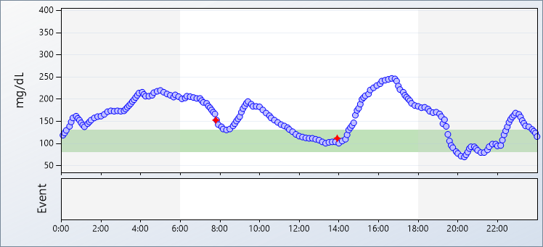 | Friday, November 13, 2015
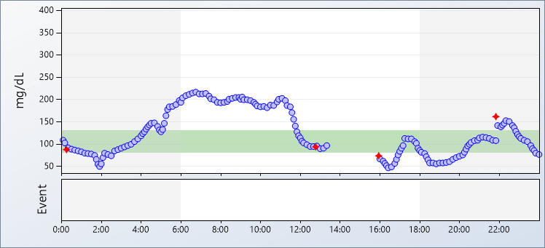 | Saturday, November 14, 2015
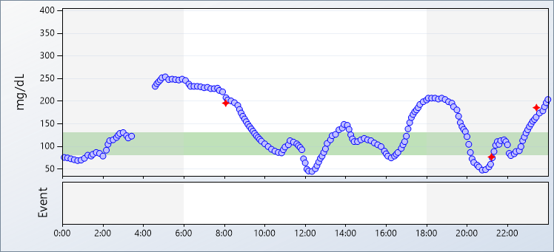 | Sunday, November 15, 2015

